Cancer Center Hub Client (CCHC) 1.1

Technical Architecture Guide

DOCUMENT CHANGE HISTORY
Version Number | Date | Contributor | Description
1.0 | 7/16/2008 | Bill McCurry | Contents for CCHC v1.1 adapted from content previously contained in CTODS Lab Viewer Technical Architecture Guide

TABLE OF CONTENTS
1 Introduction 1
1.1 Chapter Organization and Content 1
1.2 Overview of the Guide 1
1.3 Organization of the Guide 2
1.4 Intended Audience for the Guide 2
1.5 Scope of the Guide 2
1.6 Document Text Conventions 3
1.7 Related documents 4
2 Overview of the Software 5
2.1 Chapter Organization and Content 5
2.2 Software Overview 5
2.2.1 Project Background 5
2.2.2 System Overview 5
2.2.3 Features of the CCHC 5
2.3 System Requirements 6
3 Installation 7
4 Requirements 8
4.1 Chapter Organization and Content 8
4.2 Summary of Cancer Center Hub Client Requirements 8
5 Architecture 9
5.1 Chapter Organization and Content 9
5.2 System Architecture Overview 9
5.3 Architectural Design 10
6 Design 12
6.1 Chapter Organization and Content 12
6.2 Cancer Center Hub Client Design 12
6.2.1 Use Case 12
6.2.2 Process Flow 13
6.2.3 Data Folders 13
6.3 Technology Stack 13
7 Security and Security Management 15
7.1 Chapter Organization and Content 15
7.2 Software Authentication and Authorization 15
8 Information Model 16
8.1 Chapter Organization and Content 16
8.2 Lab Domain Model Development 16
8.3 Lab Domain Modeling Artifacts 16
8.4 Lab Domain Object Model 16
Appendix A References 19
Technical Manuals/Articles 19
caBIG™ Material 20
caCORE Material 20
Appendix B Glossary 21
Index 23

Introduction
The Cancer Center Hub Client (CCHC) application is used to transform clinical lab data from CSV or HL7v2 format to HL7v3 and submit it to the hub for persistence in Lab Viewer. While the CCHC is not a component of the Lab Viewer application itself, it is the easiest way for the end user to get lab data into CTODS for display in CTODS Lab Viewer.
The Technical Architecture Guide provides the software architecture and high level design for the Cancer Center Hub Client application that is a part of CCTS 1.1. This document is used as a recommendation and guideline by the development team to develop a detailed design for the system. It emphasizes the architecturally significant parts of the design model.

Chapter Organization and Content
The purpose of this chapter is to provide a high level overview of the CCHC solution, its components and the overall content of this guide.
Topics in this chapter include:
- Overview of the Guide
- Organization of the Guide

- Scope of the Guide
- Document Text Conventions
- Related documents

Overview of the Guide
This guide introduces the technical and architectural aspects of the components that make up Cancer Center Hub Client 1.1. It provides an overview of the architecture, describes the components and their use cases, identifies the technology stack and provides some technical reference.

Organization of the Guide
This table provides a summary of the focus of each chapter.
Table 1 - Main Contents of the CCHC Technical Architecture Guide
Chapter in caXchange Technical Architecture Guide | Chapter Contents
Chapter 1 | Introduction
Chapter 2 | Overview of the Software
Chapter 3 | Installation
Chapter 4 | Requirements
Chapter 5 | Architecture
Chapter 6 | Design
Chapter 7 | Security and Security Management
Chapter 8 | Information Model
Appendix A | References
Appendix B | Glossary
Index | Index

Intended Audience for the Guide
The intended audience for this document includes developers and architects interested in obtaining an overview of the architecture and high level design for the CCHC component.

Scope of the Guide
The scope of this document is limited to the requirements as identified in the 1.1 version release of the CCHC application. For additional project and requirement-specific information, please refer to the following documents:
- Software Requirements Specification (SRS)
- Use Case Specification and Realization Document
The latest versions of these documents can be found in:
https://gforge.nci.nih.gov/plugins/scmcvs/cvsweb.php/caxchange/Deliverables/?cvsroot=caxchange

Document Text Conventions
The following table shows various typefaces to differentiate between regular text and menu commands, keyboard keys, and text that you type. This illustrates how conventions are represented in this guide.
Table 2 - Document Conventions
Convention | Description | Example
Bold & Capitalized Command  Capitalized command > Capitalized command | Indicates a Menu command  Indicates Sequential Menu commands | Admin > Refresh
text in small caps | Keyboard key that you press | Press enter
text in small caps + text in small caps | Keyboard keys that you press simultaneously | Press shift + ctrl and then release both.
Special typestyle | Used for filenames, directory names, commands, file listings, source code examples and anything that would appear in a Java program, such as methods, variables, and classes. | URL_definition ::= url_string
Boldface type | Options that you select in dialog boxes or drop-down menus. Buttons or icons that you click. | In the Open dialog box, select the file and click the Open button.
Italics | Used to reference other documents, sections, figures, and tables. | caCORE Software Development Kit 1.0 Programmer’s Guide
Italic boldface type | Text that you type | In the New Subset text box, enter Proprietary Proteins.
Note: | Highlights a concept of particular interest | Note: This concept is used throughout the installation manual.
Warning! | Highlights information of which you should be particularly aware. | Warning! Deleting an object will permanently delete it from the database.
{} | Curly brackets are used for replaceable items. | Replace {root directory} with its proper value such as c:\cabio

Related documents
For additional project information, please refer to the following documents:
- Software Requirements Specification (SRS)
- Use Case Specification and Realization Document
- Design Document
- Installation Guide
- End User’s Guide
The latest versions of these documents can be found in:
https://gforge.nci.nih.gov/plugins/scmcvs/cvsweb.php/caxchange/Deliverables/?cvsroot=caxchange

Overview of the Software

Chapter Organization and Content
Topics in this chapter include:
- Project Background
- System Overview
- Features of the CCHC
- System Requirements

Software Overview

Project Background
The caXchange project consisted of the development of three components in support of CCTS 1.1. The first is the caXchange hub for exchanging clinical trial information between applications and systems. The second is the Lab Viewer for displaying clinical trial lab data stored in the CTODS Lab Domain Database. The third is the Cancer Center Hub Client that allows users to provide laboratory data in either CSV or HL7v2 format and upload it to CTODS. This guide focuses on the second and third components.

System Overview
The components detailed in this technical architecture guide deal with the handling of clinical trial lab data in CCTS 1.1. The CCHC is a client application that aids cancer centers in getting laboratory data from their existing lab systems into the CTODS Lab Domain database. It supports CSV and HL7v2 formats to support the most common data formats that existing lab systems might be able to provide. This tool transforms this data into a standard HL7v3 CT Lab message that is sent via the hub to CTODS.
The key roles in the project are defined in the following table.
Table 3 - Key Roles in the caXchange Project
Role | Name | Comments
Project Sponsor | caBIGTM
Reviewer | caBIGTM Architecture Workspace | Will review and provide guidance of architecture artifacts
Reviewer | caBIGTM Study Conduct SIG | Will provide requirements feedback
User | NCI CBIIT | Responsible for hosting the components
Developer | ScenPro, Ekagra Software Technologies | Joint development team

Features of the CCHC
Key features of the CCHC application include the following:
- Supports user authentication and authorization
- Supports data transformation via caAdapter and converts laboratory data into HL7v3 messages

System Requirements
The following table provides a very high-level summary of the requirements of the CCHC application:
Table 4 - High Level Summary of Requirements
Requirement ID | Requirement Description
2.0 | The system must provide the ability for Cancer Centers to send patient laboratory data to the caXchange. The patient lab data will be in a caAdapter required .csv format or HL7v2. The solution should not require the Cancer Center to perform any elaborate programming.

A more in-depth summary of the system requirements is presented in Chapter 4. Alternatively, a more detailed understanding of the requirements can be found in the requirements document: Software Requirements and Specification (SRS). The URL to this document is:
https://gforge.nci.nih.gov/plugins/scmcvs/cvsweb.php/caxchange/Deliverables/Updated%20Requirements%20and%20Specifications%20Document%20(Task%203.2.3).doc?cvsroot=caxchange

Installation
A separate document, the CCHC Installation Guide 1.1, outlines the steps for installing and configuring the Lab Viewer application. Please refer to that document for details. The latest version of this document can be found at
https://gforge.nci.nih.gov/plugins/scmcvs/cvsweb.php/caxchange/Documentation/installation/CTODS%20Lab%20Viewer%20Installation%20Guide%201.0.doc?cvsroot=caxchange

Requirements

Chapter Organization and Content
This chapter includes:
- Summary of Cancer Center Hub Client Requirements

Summary of Cancer Center Hub Client Requirements
This section summarizes the requirements documented in the caXchange Software Requirements Specification document for the Cancer Center Hub Client.
Table 5 - Summary of Detailed Requirements
Requirement ID | Requirement Description
2.1 | The system should minimize the local development work to send laboratory data to the caXchange
2.2 | The CCHC must be able to retrieve laboratory data in a specified format and create a message that can be sent to the caXchange.
2.3 | The CCHC must retrieve files containing the laboratory data in a .csv format from a user defined directory
2.4 | The CCHC must poll a user defined directory repeatedly for a laboratory data file with a user specified amount of time between each polling
2.5 | The CCHC must delete, rename, or move a file after it is sent to the caXchange so it will not be resent to the caXchange.
2.6 | The CCHC must be able to send the laboratory data message to the caXchange
2.7 | The CCHC must be able to log successful and unsuccessful attempts to send messages to the caXchange
2.8 | Security will be placed on the directory that the CCHC will poll for the .csv files. The security will allow only authorized users to put .csv files in the directory.
2.9 | The CCHC must be able to transform the source data into an HL7v3 format and send to the caXchange

Architecture

Chapter Organization and Content
Topics in this chapter include:
- System Architecture Overview
- Architectural Design

System Architecture Overview
The following diagram depicts the three major components of caXchange and how they relate to each other to provide a complete solution for loading clinical trial data into the CTODS Lab Domain database.
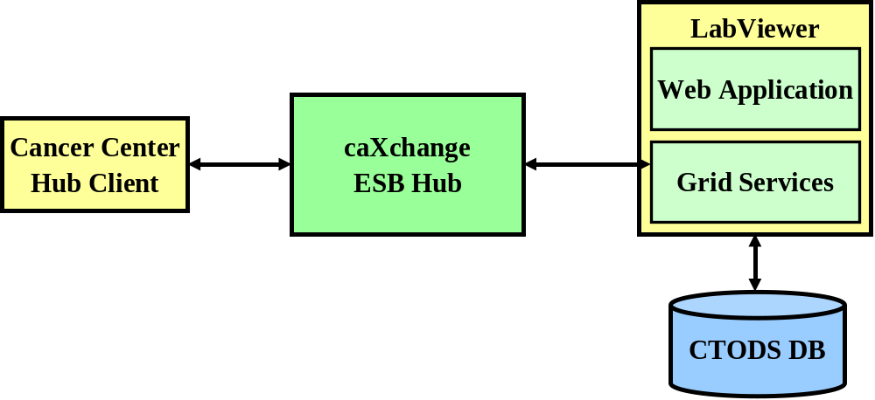
Figure 1 - caXchange High level Architecture
The Cancer Center Hub Client will be used to submit clinical trial lab data to the caXchange ESB Hub in a standard HL7v3 format. The hub will accept the data from the hub client and will route the message to the appropriate CTODS Grid Service for processing and storage in the CTODS Lab Domain Model which will make it available for display in the CTODS Lab Viewer application.

Architectural Design
This technical architecture guide covers the architecture of one of the three major components that are a part of the caXchange effort. This is the Cancer Center Hub Client that is used to submit clinical trial lab data to the hub for routing to the grid service that will persist it into the CTODS Lab Domain Database.
The following diagram depicts the components of the Cancer Center Hub Client:
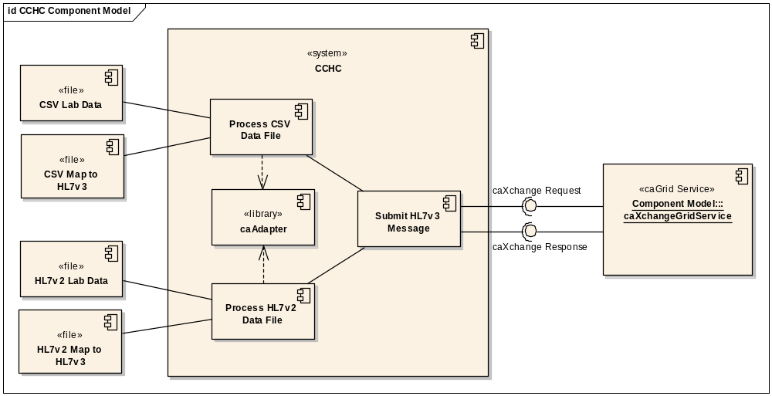
Figure 2 – Cancer Center Hub Client Component Model
The following table describes the components that make up the CCHC:
Table 6 - Summary of CCHC Components
Component | Description | Req’ts Addressed | Status
Process CSV Data File | The Process CSV Data File component reads the source CSV file and the mapping file that has been generated using caAdapter to map the CSV to HL7v3. It uses the caAdapter APIs to convert the data to HL7v3. | 2.1 – 2.5 | Mapping file had to be regenerated and caAdapter included in the CCHC
Process HL7v2 Data File | The Process HL7v2 Data File component reads the source HL7v2 file and the mapping file that has been generated using caAdapter to map the HL7v2 to HL7v3. It uses the caAdapter APIs to convert the data to HL7v3. | 2.1 – 2.5 | New Development
caAdapter | caAdapter is a product developed by NCICB for doing data transformation. The CCHC bundles the APIs within the tool for performing the transformations to HL7v3 | 2.9 | Existing product just requires some integration.
Submit HL7v3 Message | The Submit HL7v3 message component takes the completed HL7v3 message generated using caAdapter and submits it to the hub for routing to CTODS CT Lab Load Grid Service. | 2.6 – 2.7 | Modified to use the new caXchange Hub grid services

Design

Chapter Organization and Content
Topics in this chapter include:
- Cancer Center Hub Client Design
- Technology Stack

Cancer Center Hub Client Design
The Cancer Center Hub Client is the application that is used to process, transform, and submit clinical trial lab data to the caXchange hub for routing and storage in the CTODS Lab Domain database.

Use Case
The following diagram shows the use case for the Cancer Center Hub Client.
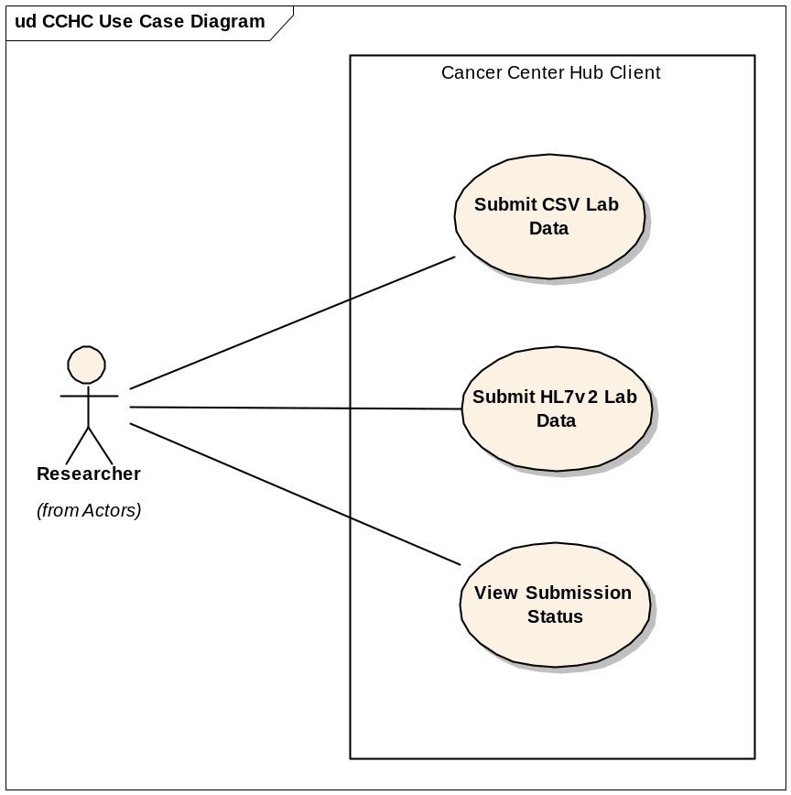
Figure 3 – Cancer Center Hub Client Use Case

Process Flow
The process flow for the Cancer Center Hub Client is as follows:
- Generate Lab Data in either CSV or HL7v2 format
- Move it to the appropriate directory to be processed
- Verify that the data was processed and submitted successfully to the hub

Data Folders
The following data folders will be created on the machine on which the Cancer Center Hub Client will be deployed and running. A description of how each one of the directories is used is provided below:
- Raw Files Folder: A folder in which data files will be placed in order to be sent to the caXchange hub. This directory is polled periodically by the client application. Once files are discovered by the polling process, the Preprocessor is invoked. The Preprocessor converts raw .csv files to a caAdapter friendly format. If the Preprocessor succeeds, the files are moved to the “In Process” folder. If the Preprocessor reports a failure, the files are moved to “Error” folder.
- In Process Folder: The CCHC application immediately attempts to transform and then send files it moves into this directory to the hub. If the send is successful, these files are moved to the “Processed” Directory. If the send is unsuccessful, the files are moved to the “Error” directory.
- Processed Folder: The client application will move all files that were successfully sent to the caXchange hub to this directory. This directory should be periodically backed up and purged.
- Error Folder: This client application will move files that were not successfully sent to the caXchange hub to this directory.
Security will be placed on all four directories to ensure only authorized personnel and processes are able to write to the directories.

Technology Stack
The following technologies are used in the CTODS Lab Viewer, Grid Services, and Cancer Center Hub Client solution or in the development of the solution:
- JDK 1.5.0
- Tomcat 5.0.28
- caAdapter 4.0
- caCORE SDK 4.0
- Oracle 10g
- caGrid 1.1
- Enterprise Architect 6.1+

Security and Security Management

Chapter Organization and Content
Topics covered in this chapter include:
- Software Authentication and Authorization

Software Authentication and Authorization
The CCHC has been configured to authenticate and authorize the user using Dorain. The CCHC UI has fields to accept the user credentials namely Authentication Service URL, User name and password.
CCHC uses these user credentials to obtain the grid credentials or proxy certificate programmatically from Dorain. This proxy certificate is used to invoke the grid service to load the HL7V3 lab messages to CTODS database. The grid service in turn performs authentication by verifying if the certificate is trusted.

Without the valid user credentials the HL7V3 lab messages cannot be persisted in the database via the grid service.
More information about how Dorain authenticates and authorizes user using their credentials may be found at:
http://www.cagrid.org/wiki/Dorian:Main

Information Model

Chapter Organization and Content
Topics covered in this chapter include:
- Lab Domain Model Development
- Lab Domain Modeling Artifacts
- Lab Domain Object Model
- CTODS Lab Domain Database Model

Lab Domain Model Development
The original Lab Domain Model was created in conjunction with the Lab Information Special Interest Group (SIG) of the CTMS Workspace. Analysts met with the SIG over the course of several months to identify and refine data elements, associations, and definitions. The starting point was a list of data elements provided by CDISC. These elements were included in the object model built in Enterprise Architect (EA). The APIs built on the CTODS Lab Domain database to retrieve lab data from CTODS are based on this object model.

Lab Domain Modeling Artifacts
The final CTODS Lab Domain model including the database model and the object model used to generate the caCORE SDK API’s were fully documented in EA. They can be found in the caXchange GForge project at the following URL.
https://gforge.nci.nih.gov/plugins/scmcvs/cvsweb.php/caxchange/Deliverables/Updated%20UML%20Static%20Class%20Diagram%20Model%20(Task%203.3.3).eap?cvsroot=caxchange

Lab Domain Object Model
The following diagram (split into two halves for easy printing) depicts the Lab Domain object model. For more information on the object mode, see the EA file referenced in the URL above.

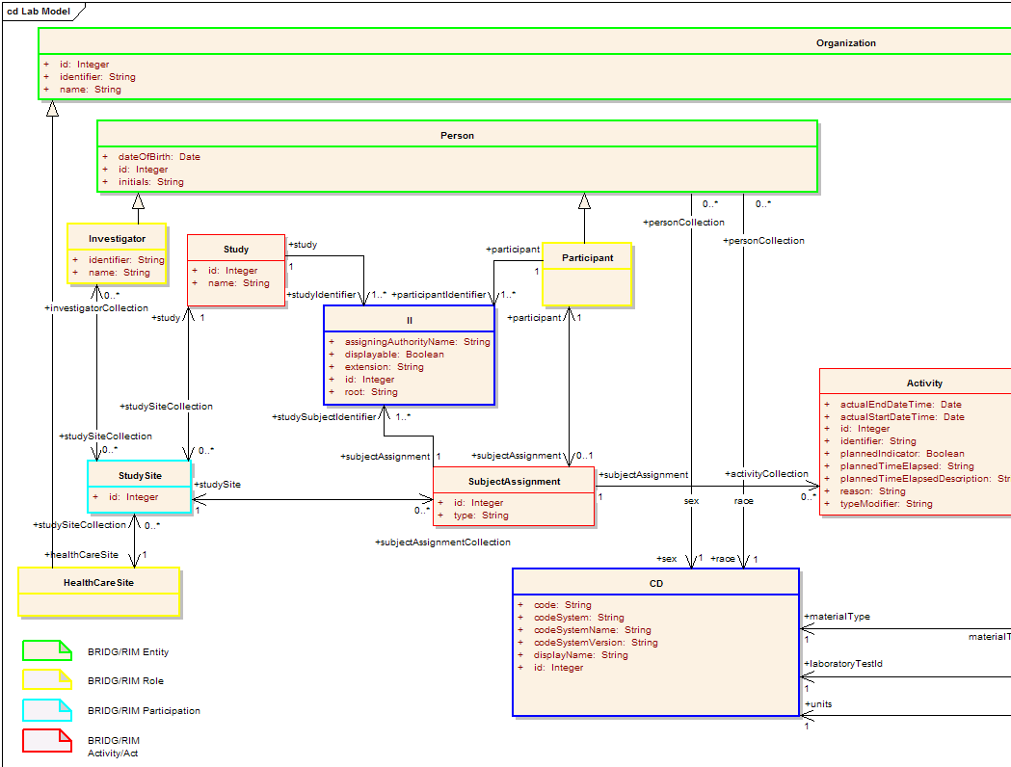
Figure 4 – CTODS Lab Domain Object Model - Left Half
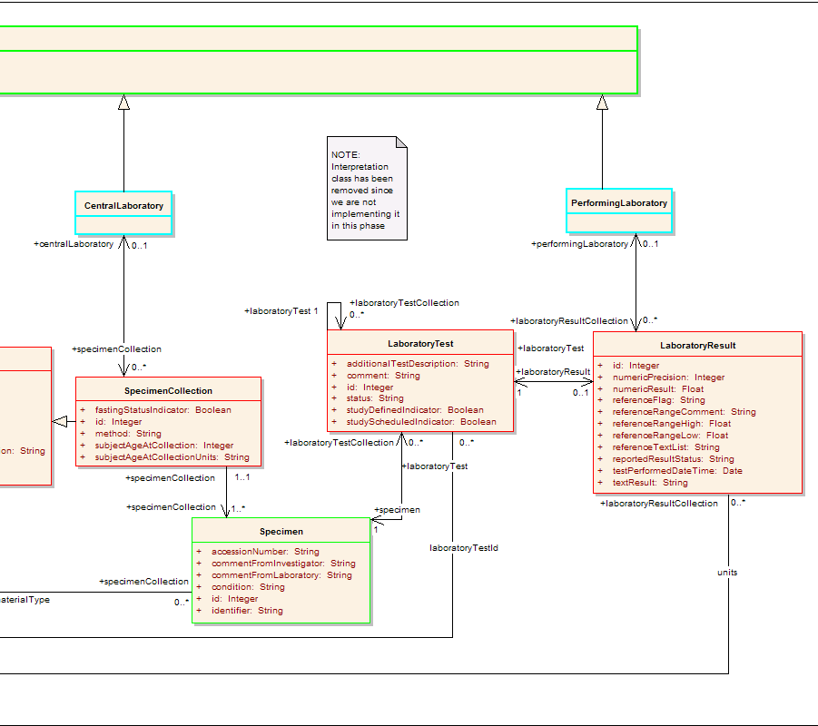
Figure 5 – CTODS Lab Domain Object Model - Right Half
Appendix A References

Technical Manuals/Articles
- National Cancer Institute. “caCORE SDK 3.2 Programmers Guide”,
http://ncicb.nci.nih.gov/infrastructure/cacoresdk
- Java Bean Specification:
http://java.sun.com/products/javabeans/docs/spec.html
- Foundations of Object-Relational Mapping:
http://www.chimu.com/publications/objectRelational/
- Object-Relational Mapping articles and products:
http://www.service-architecture.com/object-relational-mapping/
- Hibernate Reference Documentation:
http://www.hibernate.org/hib_docs/reference/en/html/
- Basic O/R Mapping:
http://www.hibernate.org/hib_docs/reference/en/html/mapping.html
- Java Programming:
http://java.sun.com/learning/new2java/index.html
- Javadoc tool:
http://java.sun.com/j2se/javadoc/
- Junit:
http://junit.sourceforge.net/
- Extensible Markup Language:
http://www.w3.org/TR/REC-xml/
- XML Metadata Interchange:
http://www.omg.org/technology/documents/formal/xmi.htm

caBIG™ Material
- caBIGTM:
http://cabig.nci.nih.gov/
- caBIGTM Compatibility Guidelines:
http://cabig.nci.nih.gov/guidelines_documentation

caCORE Material
- caCORE:
http://ncicb.nci.nih.gov/core
- caBIO:
http://ncicb.nci.nih.gov/core/caBIO
- caDSR:
http://ncicb.nci.nih.gov/core/caDSR
- EVS:
http://ncicb.nci.nih.gov/core/EVS
- CSM:
http://ncicb.nci.nih.gov/core/CSM
Appendix B Glossary
Term | Definition
API | Application Programming Interface
caBIG | cancer Biomedical Informatics Grid
caBIO | Cancer Bioinformatics Infrastructure Objects
caCORE | cancer Common Ontologic Representation Environment
cardinality | Cardinality describes the minimum and maximum number of associated objects within a set
CDISC | Clinical Data Interchange Standards Consortium
CSM | Common Security Module
CTMS | Clinical Trial Management Systems
CVS | Concurrent Versions System
DAO | Data Access Objects
DAS | Distributed Annotation System
EA | Enterprise Architect
EBI | European Bioinformatics Institute
EVS | Enterprise Vocabulary Services
GULCCC | Georgetown University Lombardi Cancer Center
HIPPA | Health Insurance Portability and Accountability Act
HTTP | Hypertext Transfer Protocol
ISO | International Organization for Standardization
JAAS | Java Authentication and Authorization Service
JAR | Java Archive
Javadoc | Tool for generating API documentation in HTML format from doc comments in source code (http://java.sun.com/j2se/javadoc/)
JBI | Java Business Integration
JDBC | Java Database Connectivity
JET | Java Emitter Templates
JMI | Java Metadata Interface
JSP | JavaServer Pages
JUnit | A simple framework to write repeatable tests (http://junit.sourceforge.net/)
LDAP | Lightweight Directory Access Protocol
LLT | Log Locator Tool
LOINC | Logical Observation Identifier Names and Codes
MedDRA | Medical Dictionary for Regulatory Activities
metadata | Definitional data that provides information about or documentation of other data.
Multiplicity | Multiplicity of an association end indicates the number of objects of the class on that end may be associated with a single object of the class on the other end
NCI | National Cancer Institute
NCICB | National Cancer Institute Center for Bioinformatics
OMG | Object Management Group
ORM | Object Relational Mapping
RDBMS | Relational Database Management System
SDK | Software Development Kit
Semantic connector | A development kit to link model elements to NCICB EVS concepts.
SIG | Special Interest Group
SQL | Structured Query Language
UI | User Interface
UID | User Identification
UML | Unified Modeling Language
UMLS | Unified Medical Language System
UPT | User Provisioning Tool
URL | Uniform Resource Locators
WAR | Web Application Archive
WSDL | Web Services Description Language
XMI | XML Metadata Interchange (http://www.omg.org/technology/documents/formal/xmi.htm) - The main purpose of XMI is to enable easy interchange of metadata between modeling tools (based on the OMG-UML) and metadata repositories (OMG-MOF) in distributed heterogeneous environments
XML | Extensible Markup Language (http://www.w3.org/TR/REC-xml/) - XML is a subset of Standard Generalized Markup Language (SGML). Its goal is to enable generic SGML to be served, received, and processed on the Web in the way that is now possible with HTML. XML has been designed for ease of implementation and for interoperability with both SGML and HTML

Index

APIs, 6
Architecture, 10, 11
C3PR, 6
caAdapter, 6
Client, 9
component, 1, 2, 5, 6, 10, 11, 12, 13
CTODS, 1, 5, 6, 7, 8, 10, 11, 12, 13, 14, 15, 16, 17, 18, 19, 20, 21, 22, 23, 24, 25
Database Model, 23
Features, 6
Folders, 21
Grid, 8, 9, 11, 12, 13, 14, 17, 18, 19, 21, 22, 28
HL7, 1, 5, 6, 8, 9, 11, 12, 13, 19, 20
Hub, 1, 5, 8, 9, 11, 12, 13, 14, 17, 18, 19, 20, 21
Installation, 4, 7
Object Model, 23, 24, 25
Persistence, 1
Process Flow, 15, 17, 18, 20
Requirements, 2, 4, 5, 6, 8, 9
Security, 8, 9, 21, 22, 28
Sequence Diagram, 16, 18, 19
Use Case, 1, 2, 4, 14, 15, 17, 20
Web Service, 12, 29
WSDL, 29

